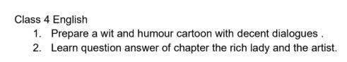
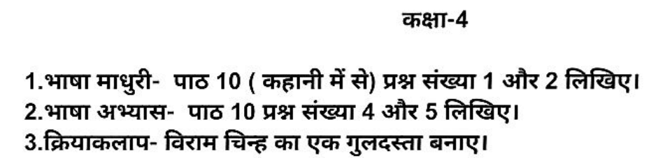


CLASS 4 HHW Subject: - Science
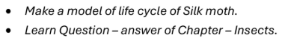
CLASS 4 HHW Subject: - Social Studies


CLASS 4 HHW Subject: - COMPUTER
Do in Computer HHW copy.
- Write commands to draw these shapes in LOGO. Also draw the shapes.
  - Square
  - Triangle
  - Pentagon
  - Hexagon
  - Circle
- Write full form of the following:
  - PD
  - PU
  - HT
  - ST
  - PE

