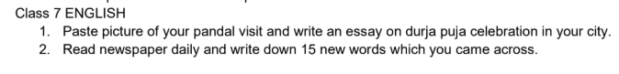

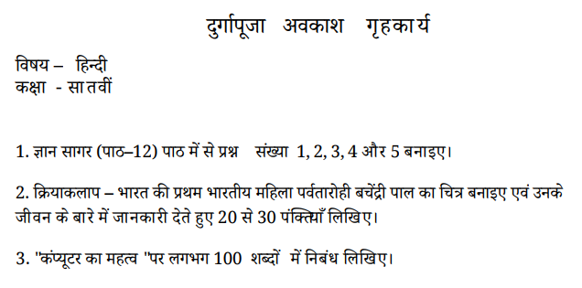

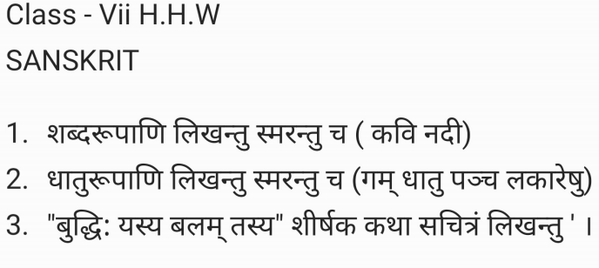
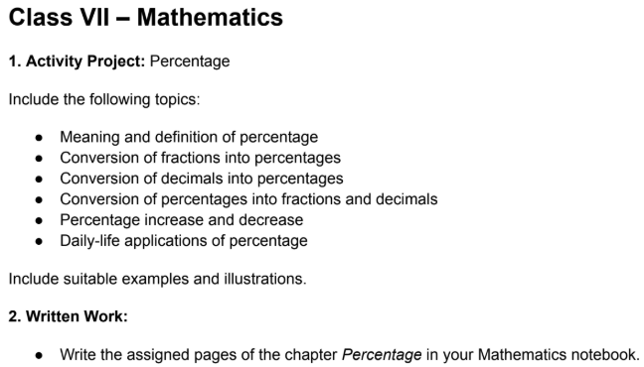
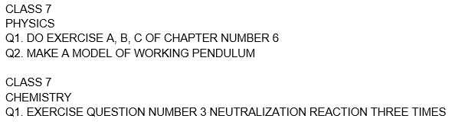
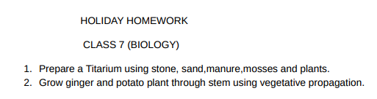
CLASS 7 HHW Subject: - Social Studies
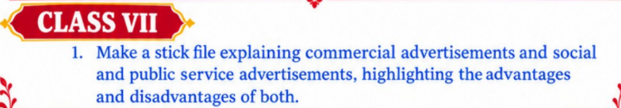

CLASS 7 HHW Subject: - COMPUTER
Do in Computer HHW copy.
- Draw any four tools used in GIMP. Also, write their functions.
- Write functions of the following:
  - Email
  - Social networking websites
  - Chatting

