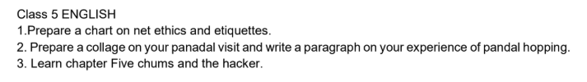
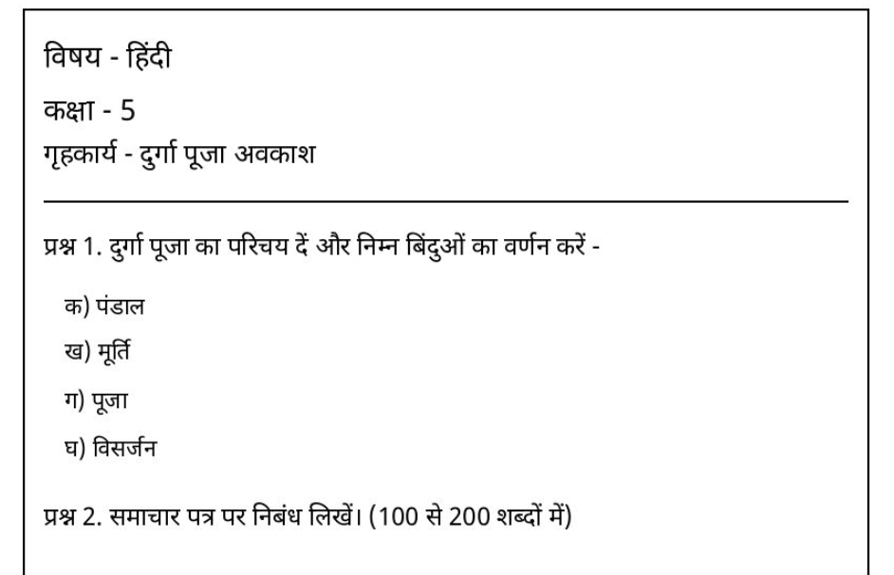
Sanskrit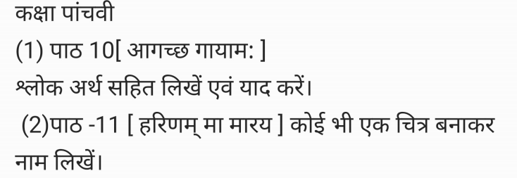
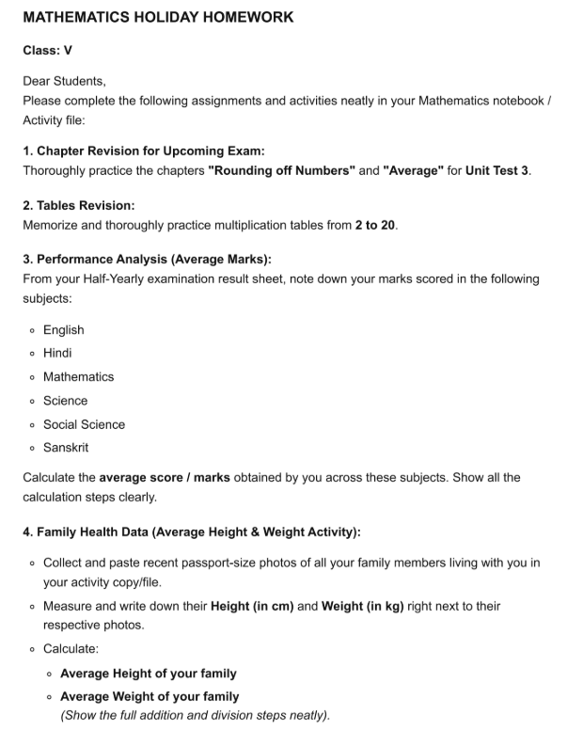

CLASS 5 HHW Subject: - Science
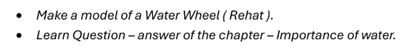
CLASS 5 HHW Subject: - Social Studies
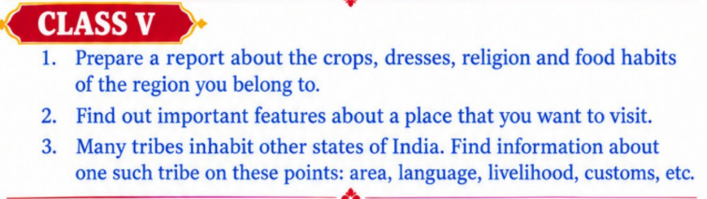
CLASS 5 HHW Subject: - COMPUTER
Do in Computer HHW copy.
- Write two uses of fontwork.
- Design a birthday card using fontwork features.
- Write different ways to insert pictures in a document.

