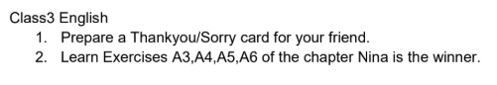
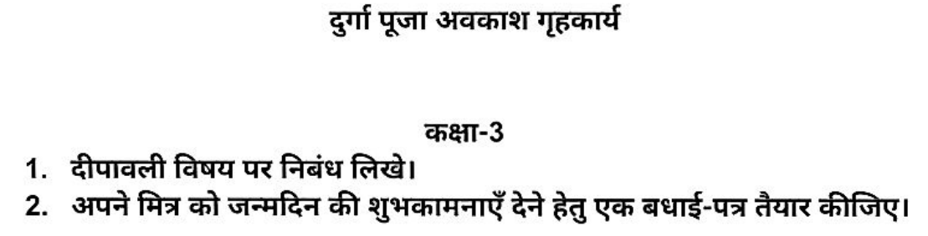

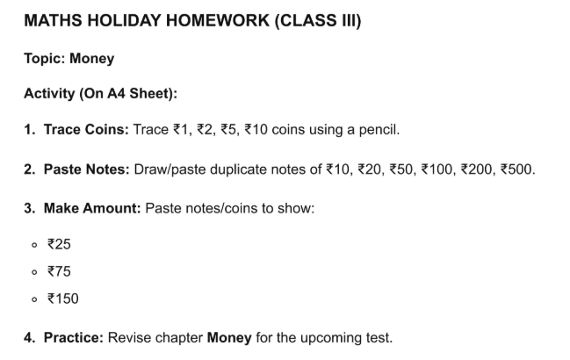

CLASS 3 HHW Subject: - Science
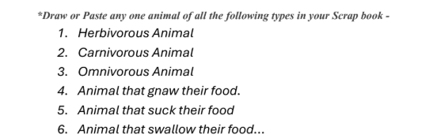

CLASS 3 HHW Subject: - Social Studies

CLASS 3 HHW Subject: - COMPUTER
Do in Computer HHW copy.
1. Draw, colour and write about these keys:-
a) Caps Lock key
b) Shift Key
c) Backspace key
d) Delete key
e) Num Lock key

