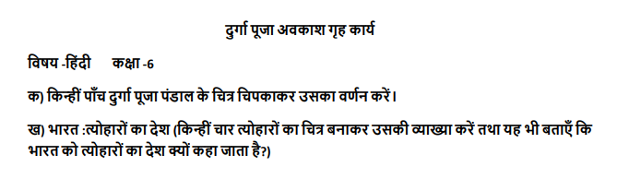
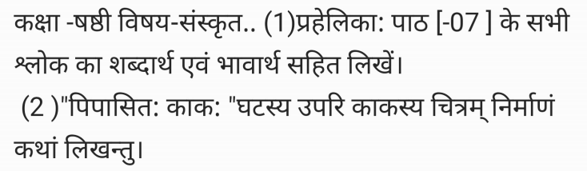
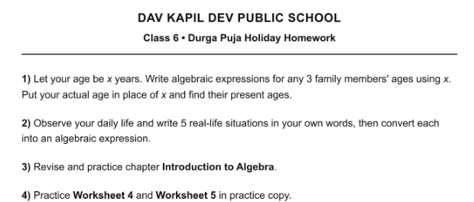
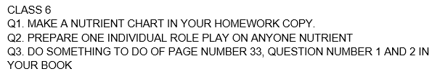
CLASS 6 HHW Subject: - Social Studies
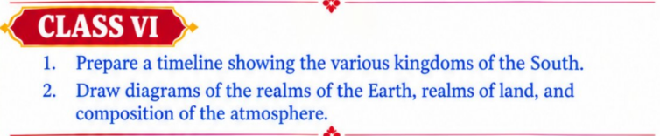
CLASS 6 HHW Subject: - COMPUTER
Do in Computer HHW copy.
- Name different views available in impress.
- Differentiate between normal and notes view.
- Differentiate between slide show and slide sorter view.

